Findings Week1

1. **HLA Class I1 Genes Associated with REM Sleep Behavior Disorder: 7**

**Authors: *Carlos H. Schenck, MD,*t Edgar Garcia-Rill, PhD,$* *Miriam Segall, PhD,' Harriet Noreen, CHS,\*\** *and Mark W. Mahowald, MD*$***

Read the above paper :

* **HLA Class II gene complex:** *The human leukocyte antigen (HLA) system (the major histocompatibility complex [MHC] in humans) is an important part of the immune system and is controlled by genes located on chromosome 6 , p arm .*
* *It encodes****cell****surface molecules specialized to present antigenic peptides to the T-****cell****receptor (TCR) on T cells.*
* *Rapid eye movement ( E M ) sleep behavior disorder (RBD) is a parasomnia that mainly affects middle-aged or older men*

**The following genes from the HLA Class II family were found in the patients.**

DQB1: Most common phenotype: Cell Immunity

DR2:

DRB1

DRB3

DRB4

DRB5

All are involved in cell immunity, and APC

The strong *dissociation* between DQwl and DR2 in RBD can be contrasted with the very strong DQwl-DR2 *association* in narcolepsy.

1. **The role of circadian clock genes in mental disorders 1**

***Authors: Elaine Waddington Lamont, PhD; Daniel Legault-Coutu, MSc; Nicolas Cermakian, PhD; Diane B. Boivin,MD, PhD***

GSK3 Enzyme

ARNTL protein by Bmal1 gene

NPAS2: involved in Circadian Rhythms: Also involved in Seasonal Affective Disorder

1. **Predictors of Elevated Nuclear Factor-_B–dependent Genes in Obstructive Sleep Apnea Syndrome**

***Authors: Silke Ryan, Cormac T. Taylor, and Walter T. McNicholas***

-Redundant-

1. **Circadian Rhythms in the CNS and Peripheral Clock Disorders: Human Sleep Disorders and Clock Genes 1**

**CK1 delta :**

The core of the biological clock (central generator of the circadian rhythm) is thought to consist of interactions of **approximately ten “clock genes**”, including Per1/2/3, Cry 1/2, Bmal1, Clock, and **casein kinase 1 delta /epsilon (CK1δ/ ε)** (7). Per1/2/3, Cry 1/2, Bmal1, and Clock code for transcriptional factors, while

**CK1δ/ ε code for kinases that phosphorylate these transcriptional**

**factors.**

1. **Genes for normal sleep and sleep disorders**

***Authors: MEHDI TAFTI1, STE´ PHANIE MARET1 & YVES DAUVILLIERS***

**PRNP** Gene **2**

A point mutation (codon 178) in the prion protein gene (**PRNP)** on chromosome 20 and rarely a mutation at codon 200 (21) have been identified in FFI(Fatal familial insomnia)

A pseudohypersomnia behavior could be observed instead of an insomnia complaint in FFI with heterozygosity at PRNP codon 129

The PrP has been shown to participate in several biological processes, including neuritogenesis, neuronal homeostasis, **cell** signalling, **cell** adhesion, and a protective role against stress.

DQA1

DR2

immunity

The high activity allele of the MAOA gene may represent a modifying factor involved in

the severity of RLS(Restless-legs syndrome) manifestations in female patients only

*--Not that clear--*

A recent study reported a large kindred

with 11 patients affected both by Charcot-Marie-

Tooth 1A disease (duplication of PMP22 gene) and

SAS(Sleep apnea syndrome), suggesting a pathophysiological mechanism

common to both conditions.

Moreover, the marked concordance in chemo-respiratory responses

observed in MZ twins also appears to underscore the

importance of central factors in the genetic control

of respiration.

The homeobox PHOX2B gene, for

instance, is involved in the normal patterning of the

autonomous ventilatory system and heterozygous de

novo mutations in PHOX2B (5-9 alanine expansions

within a 20-residue polyalanine) were found in 18

out of 29 patients affected with congenital central

hypoventilation syndrome.

*--Not that clear—*

1. **Diurnal Rhythmicity Programs of Microbiota and Transcriptional Oscillation of Circadian Regulator, NFIL3**

***Authors: Masato Kubo* 1**

Clock regulating transcription factor NFIL3 (also called E4BP4), which influences the circadian clock in intestinal epithelial cells through the regulation of group 3 innate lymphocyte cells

1. **Systematic Analysis of Circadian Genes in a Population-Based Sample Reveals Association of TIMELESS with Depression and Sleep Disturbance 5**

***Authors: Siddheshwar J. Utge, 1 , 2 , 3 , 4 Pia Soronen, 1 , 3 , 4 Anu Loukola, 1 , 4 Erkki Kronholm, 5 Hanna M. Ollila, 1 , 2 , 4 Sami Pirkola, 3 , 6 Tarja Porkka-Heiskanen, 2 Timo Partonen, 6 and Tiina Paunio***

ARNTL2 aryl hydrocarbon receptor nuclear translocator-like 2 [40]

TIPIN TIMELESS interacting protein [87]

**Tipin and Timeless form a mutually protective complex required for genotoxic stress resistance and checkpoint function**

***Danny M. Chou and Stephen J. Elledge\****

NR1D1 nuclear receptor subfamily 1, group D, member 1 [40], [88], [89]

DBP D site of albumin promoter (albumin D-box) binding protein [40]

CSNK1E casein kinase 1, epsilon [40], [49]

1. **Database for Sleep Genes** [**https://maayanlab.cloud/Harmonizome/gene_set/sleep+disturbance/GWASdb+SNP-Phenotype+Associations**](https://maayanlab.cloud/Harmonizome/gene_set/sleep+disturbance/GWASdb+SNP-Phenotype+Associations)
2. **Genetics of narcolepsy and other major sleep disorders 2/3**

**Stéphanie Maret, Mehdi Tafti -Redundant-**

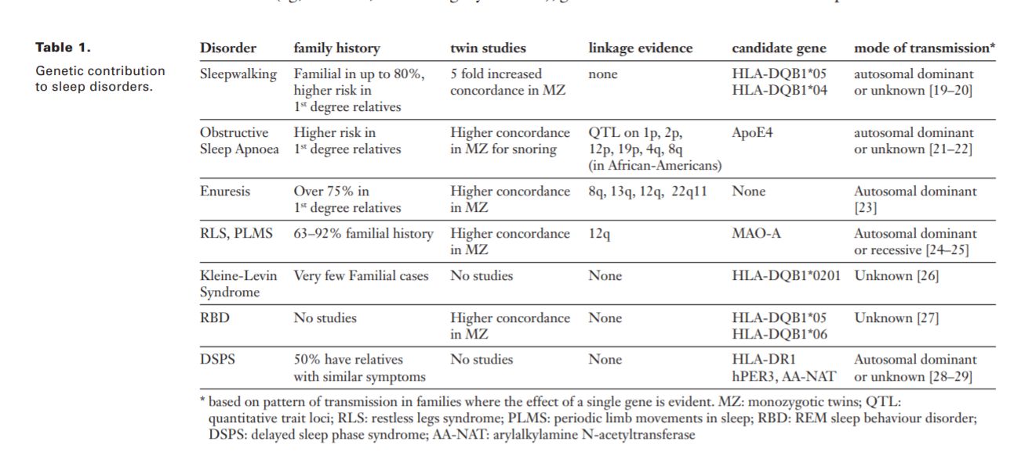

**ApoE4**

**AANAT**

**DR1**

1. **Genetics of Sleep and Sleep disorders**

***Amita Sehgal1,* and Emmanuel Mignot2 3***

Human Susceptibility Loci for Sleep and Sleep Disorders

# Table 2

Human Susceptibility Loci for Sleep and Sleep Disorders

|  |  |  |  |  |  |
| --- | --- | --- | --- | --- | --- |
| **­** | **Pathology** | **Experimental Design** | **Associated SNP, Allele, or Mutation** | **Allelic Odds Ratio** | **Comments** |
| DQB1 and DQA1 (forming the DQ heterodimer) | Narcolepsy/hypocertin deficiency | Candidate gene | Main predisposing effect is DQB1*06:02–DQA1*01:02; Secondary predisposing effects: DQB1*03:01; Secondary protective effects: DQA1*01, DQB1*05, or DQB1*06 that are not DQA1*01:02, DQB1*06:02. | OR0602 = 8.8 (Caucasians) | Effects conserved across African Americans, Asians, and Caucasians. Most effects in these loci are dominant mediated by DQ01*06:02; very few cases are DQB1*06:02 negative. Almost all subjects are DQ1*0:102, an allele in tight linkage with DQB1*06:02. |
| CPT1B/CHKB | Narcolepsy/hypocrerin deficiency Essential hypersomnia | GWAS | rs5770917C (affect expression) | OR= 1.8 (Japanese only) | Association is still tentative. Identified in Japanese narcolepsy patients, replicated in Koreans. The association is not significant in European populations or those of African descent. Did not replicate in a Chinese narcolepsy sample. Also associated with hypersomnia in Japan. Loci have roles in beta-oxidation and acetylcholine synthesis, potentially modulating rapid eye movement (REM) sleep. |
| TCRA | Narcolepsy/hypocretin deficiency | GWAS | rs1154155C (may modify TCRJ usage or sequence) | OR= 1.7 (all ethnic groups) | Identified in Caucasian narcolepsy patients and replicated across ethnic groups (Asians and African Americans). Independently replicated in European and Chinese narcolepsy patients and in Japanese cases with HLA (human leukocyte antigen)-positive essential hypersomnia. This suggests the involvement of a specific T cell receptor on narcolepsy patients, possibly interacting with the DQ locus. |
| P2RY11 | Narcolepsy/hypocretin deficiency | GWAS | rs2305795A (affect expression) | OR= 1.3 | Identified in Caucasians, with replication across ethnic groups; not yet replicated independently; immunomodulator y function or reduced ATP-induced apoptosis of immune cells. |
| HPER2 | Familial advanced sleep phase syndrome | Candidate gene sequencing | S662G (removal of a functional phosphorylation site) | n.a. (fully penetrant) | Autosomal-dominant transmission; validation in in vitro and mice models. |
| CK1d | Familial Advanced Sleep Phase Syndrome | Candidate gene sequencing | T44A (reduced kinase activity of the enzyme) | n.a. (fully penetrant) | Autosomal-dominant transmission; validation in in vitro and mice models |
| DEC2 | Familial short Sleep | Candidate gene sequencing | P385R (reduced Clk/B mal1-mediated transactivation by DEC2) | n.a. (fully penetrant) | Autosomal-dominant transmission (allele dosage model); validation in in vitro and mice models. |
| MEIS1(a) | Restless leg syndrome | GWAS | rs6710341A-rs12469063G haplotype | OR = 2.0 (Caucasians) | Identified in Caucasians; replicated by multiple studies in Caucasians; decreased expression in restless leg syndrome (RLS); function still unknown in mice. MEIS1 functions in CNS and motor neuron development. |
| MEIS1/ETAA1 (b) | Restless leg syndrome | GWAS | rs6747972A | OR= 1.2 (Caucasians) | Independent association; intergenic region on chromosome 2p14 located 1.3 MB dowstream of MEIS1; likely regulates MES1 or ETAA1 expression. |
| BTBD9 | Restless leg syndrome | GWAS | rs9296249T | OR =1.7 (Caucasians) | Replicated by multiple studies in Caucasians; also associated with periodic leg movements during sleep independent of RLS; risk allele may be associated with decreased ferritin (more prominent in women than in men); allele dosage model; involvement in RLS unknown. |
| MAP2K5/SKOR1(LBXC OR1) | Restless leg syndrome | GWAS | rs1026732G | OR= 1.5 (Caucasians) | Most likely LBXCOR1 (SKOR1); recessive effect; allele dosage model; gene has a function in the development of the CNS/spinal cord/dorsal horn; involvement in RLS unknown. |
| PTPRD | Restless leg syndrome | GWAS | rs4626664T, rs1975197A | OR= 1.4 (Caucasians) | Replicated independently in Caucasian populations; allele dosage model; involvement in RLS unknown. In principle, it functions during the development of the CNS/motorneuron and in axon guidance. |
| TOX3, noncoding [BC034767](https://www.ncbi.nlm.nih.gov/nuccore/BC034767) RNA | Restless leg syndrome |  | rs3104767G | OR =1.3 (Caucasians) | TOX3 is a well-known breast cancer susceptibility gene, but it associates with a different SNP. Genome-wide significant but no clear functional data or independent replication. |
| NOS1 | Restless leg syndrome | Case-control association in RLS linkage region | rs7977109A | OR = 0.76 (Caucasians) | Not yet replicated; involvement in RLS unknown; suggested to modulate the dopaminergic neurotransmission; different variants across the gene were associated in two case-control studies. |

**Week 3 Findings**

1. 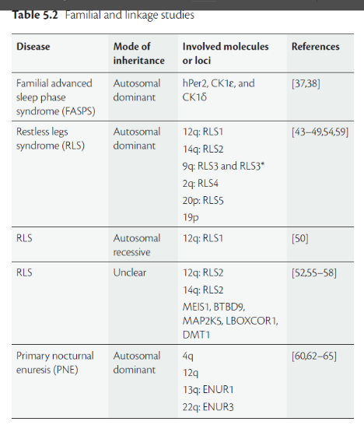Oxford Textbook of sleep; Chapter 5: **9**

The genetics of sleep

By; Alexandra Sousek and Mehdi Tafti

LBOXCOR1, (It may be also known as SKOR1)

SLC11A2/DMT1

ENUR1

ENUR3

RLS2

RLS1

RLS3

RLS4

RLS5

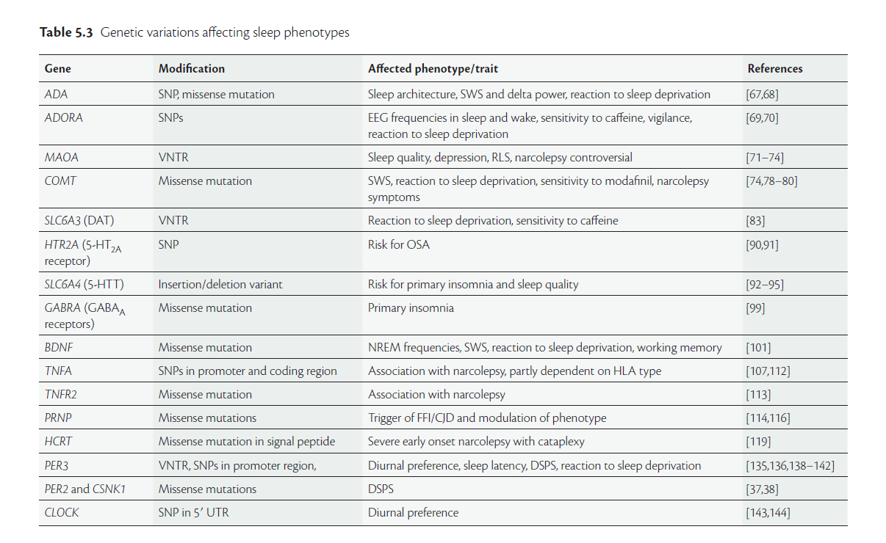

1. **Do genes matter in sleep?-A comprehensive update Rajib Dutta* MD Neurology, India**

[**https://www.heighpubs.org/jnnd/pdf/jnnd-aid1029.pdf**](https://www.heighpubs.org/jnnd/pdf/jnnd-aid1029.pdf)

**SLC6A3(DAT)**

**BDNF**

**ADORA (ADORA2A)**

**TNFR2**

**GABRA (GABA A receptors): family**

*Screening for mutations in ligand- binding domains of the α1, β3, and γ2 genes of the GABAA receptor revealed a heterozygous missense mutation in one patient with chronic insomnia. The substitution of arginine for histidine presumably entails reduced GABAergic inhibition [99]. (Book Ch-5)*

**HTR2A (5-HT2A receptor):**

Updated database with Genes

|  |  |  |
| --- | --- | --- |
| **Phenotype** | **Encoded protein function** | **Genes** |
| Sleep Disorders | Circadian Rhythm | 1. CLOCK, 2. TIMELESS, 3. PER1, 4. PER2 5. PER3, 6. CRY1, 7. CRY2, 8. RORA, 9. ARNTL, 10. CSNK1D, 11. HCRT, 12. BTBD9 13. NPAS2 14. NFIL3 15. DBP 16. CSNK1E 17. NR1D1 18. TIPIN 19. ARNTL2 20. AANAT |
| Sleep Disorders | Neurotransmission/  Cell Signalling | 1. ADRA2A, 2. SLC6A11, 3. PTPRD, 4. SLC6A13, 5. SLC6A4, 6. NOS1, 7. ADA, 8. HNMT, 9. CHRND, 10. COMT, 11. FMR1 12. **PRNP** 13. MAO-A 14. BDNF 15. SLC6A3 16. GABRA |
| Sleep Disorders | G-Protein coupled  receptors | 1. P2RY11, 2. DRD5, 3. GABBR2 4. ADORA2A 5. HTR2A |
| Sleep Disorders | Transcriptional  Corepressors | 1. SKOR1, 2. BHLHE41 3. DEC2 |
| Sleep Disorders | Transcriptional  Activators | 1. TOX3, 2. MEIS1, 3. PPARGC1B |
| Sleep Disorders | Cell Proliferation/  Cell Immunity | 1. TNFA, 2. NF-kB, 3. IL-5, 4. CIITA, 5. MAP2K5, 6. ETAA1, 7. PDCD2L, 8. ROR1, 9. DMPK, 10. DQB1: 11. DR1 12. DR2: 13. DRB1 14. DRB3 15. DRB4 16. DRB5 17. DQwl 18. DQA1 19. **TNFR2** 20. LBOXCOR1, |
| Sleep Disorders | Unknown/Other | 1. CHKB, 2. CPT1B 3. ENUR1 4. ENUR3 5. APoE4 6. RLS2 7. RLS1 8. RLS3 9. RLS4 10. RLS5 11. DMT1/SLC11A2 12. TCRA |